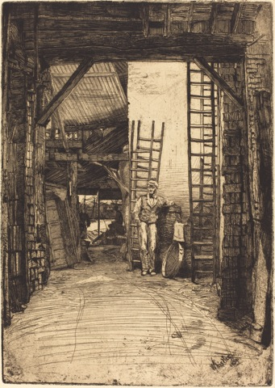Answers

**Closer Look at *The Lime-Burner* and *The Doorway***

1. Imagine walking through the entry in *The Lime-Burner* to the river in the background. What would you pass as you walked back to the distant river? *ladders, sieve, standing man wearing cap and vest, towel, boat, indistinct sitting man, wood and brick walls*

Describe the surface of the path you would walk on. *It seems smooth, perhaps hard packed dirt with wagon ruts and pebbles or litter along the edges.*

What would you see if you looked up? *Dark wooden rafters are in the foreground. Because light shines on the lime burner, this may be a courtyard open to the sky. Behind the standing man is a wooden beam and a variety of wooden ceilings beyond` this.*

2. Write a word or phrase describing the building in **A**. *terms like ramshackle, industrial, disorderly, junky, dirty, multilevel*

**A**

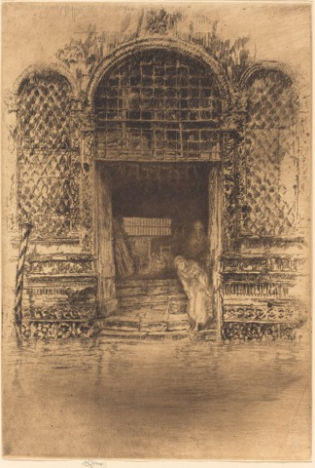3. Write a word or phrase describing the building in **B**. *terms like arches, once grand Venetian house on canal, tiles, ornate, dark interior. Steps suggest that it is need of repair.*

4. In which print is the viewer closer to the entry? *A*

5. In which print is the main person drawn in most detail? *A*

6. Compare the vertical sides of each print.

Which are darker? *A*

Drawn in most detail? *A*

7. What was Whistler most interested in showing in **A**? *standing man and interior of the building, real ordinary life scene*

8. What was Whistler most interested in showing in **B**? *Exterior of the building, an exotic (to London) scene in a beautiful piece of art*

**A** [James McNeill](http://www.nga.gov/content/ngaweb/Collection/artist-info.1974.html) Whistler, [*The Lime-Burner*](http://www.nga.gov/content/ngaweb/Collection/art-object-page.37577.html), 1859, Etching, National Gallery of Art

**B** James McNeill Whistler, *The Doorway*, 1879/80, Etching, National Gallery of Art

**B**