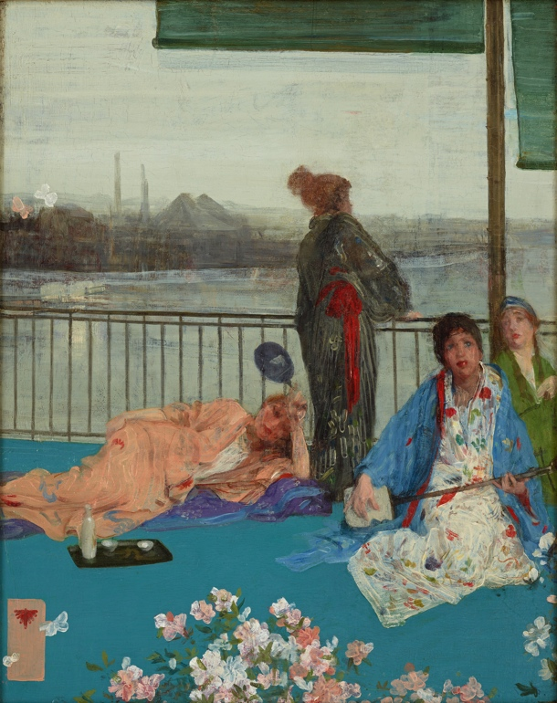 Answer Sheet

On the left is James McNeill Whistler’s oil painting, *Variations in Flesh Colour and Green: The Balcony*, 1864-70.

Look carefully at a large image of this painting for a few minutes before answering the following questions.

**Observe and Analyze**

1. Write the corresponding letter on each of these objects in the painting:

**A** Balcony railing *Model leans against it as it cuts across middle of picture plane*

**B** Thames River *Behind railing*

**C** Cherry blossoms *lower edge*

**D** Industrial city *landscape above river in background*

**E** Horizon line *just above the cityscape in the background.*

**F** Foggy London sky and atmosphere *above and around the city and smokestacks, point out the smoke on the left*

**H** Japanese fan *held by reclining woman*

**G** Kimono (long, wide-sleeved Japanese robe worn with an obi tied around the waist.) *All these women are in loose robes, but the one standing wears a kimono with an obi*

**I** Shamisen (a Japanese three-stringed music instrument) *Woman in white print and blue robe holds the shamisen*

**J** Sake set (for serving a Japanese alcoholic beverage made from rice) *near the reclining woman’s knees*

**K** Butterflies *lower left corner and near the middle edge on the left*

**L** Artist’s chop mark, similar to a Japanese seal *lower left corner*

2. From his title, we know Whistler was experimenting with color. Locate different flesh tones in this painting. Where has Whistler repeated various shades of pink and flesh tones? *Faces, arms, hands, flowers, chop mark background*

3. Which main lines tie the composition to the edge of the picture frame? *Vertical pole on left and the horizontal balcony line*

4. Describe the brushstrokes on the kimonos and background landscape. *The brushstrokes vary but many are visible, long ribbon-like, and sketchy.*

5. What part of this painting is most abstract, with the fewest recognizable details?*The cityscape in the background hazy fog*

**Interpret** – 6. What happened in Japan that enabled Whistler and other European artists to see Japanese art? Japan opened up to trade with western nations. *As Japanese prints and porcelain appeared in European cities, European artists were fascinated with its exotic articles and art compositions.*